Chapter 14, Problem 57.

Determine the center frequency and bandwidth of the bandpass filters in
Fig. 14.88.

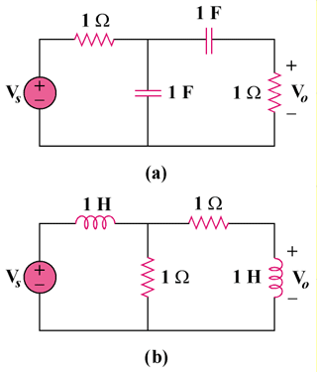

Figure 14.88
For Prob. 14.57.

